

eInspections User Guide Instructions Instructions Instructions InsteuinsInstructInstructions Instructions



*TDLR eInspections Apps*

***Prepared for***

Texas Department of Licensing and Regulation

06/21/2022

Version 1.0

***Prepared by:***

Daisy Wilke



Technical Design Document



Contents

Power Apps Mobile App User Guide 2

Install TDLR eInspection Mobile (Canvas App) 2

Install TDLR eInspection (Model Driven App) 3

Overview of Power Apps Mobile Apps 5

Add a shortcut for eInspection Apps 5

Close TDLR eInspection Mobile (Canvas App) 6

Close TDLR eInspection (Model Driven App) 7

Go Offline – TDLR einspection(Model Driven App) - preferred 8

Go Offline – TDLR eInspection Mobile(Canvas App) 9

Desktop User Guide 10

Environment Links 10

Which environment am I in? 10

Manager DTE Approvals 11

Approve DTE inspections from eInspection App 11

References 12

# Power Apps Mobile App User Guide

## Install TDLR eInspection Mobile (Canvas App)

1. Install Power App Mobile from the [App Store](https://itunes.apple.com/app/powerapps/id1047318566?mt=8)
2. Before signing in – update your Regional Settings to **US Government GCC**, If you are signed in sign out.

1. Sign in using your Azure Active Directory credentials or using the Microsoft Authenticator App
2. You will land on the All Apps screen. Type in TDLR eInspection Mobile

Select the app to open it.

Figure 1 Search for eInspection Apps

## Install TDLR eInspection (Model Driven App)

1. Go to **Settings** menu Settings button, and then turn on **Show non-production apps**.

Figure 2 Show non-production apps

1. Then Go to All Apps and search for TLDR eInspection

Figure 3 Search for eInspection Apps

1. Select the App to open it

## Overview of Power Apps Mobile Apps

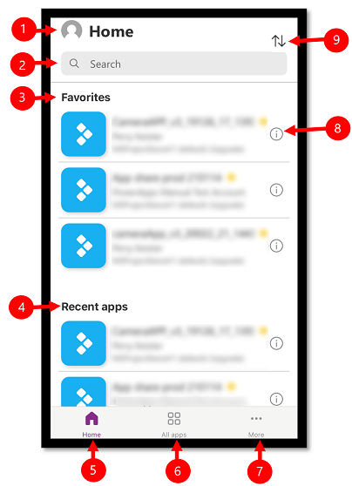

Figure 4 Power Apps Mobile Overview

1. **Settings**: Access app settings and sign out.
2. **Search**: Use the search to search for apps. When you run a search, it will only search for apps that are on the screen you're on.
3. **Favorites** (canvas apps only): Displays canvas apps that you have pinned to favorites.
4. **Recent apps**: Displays both model-driven and canvas apps that you have recently used.
5. **Home**: Displays favorite apps and recently accessed apps sorted by open date.
6. **All apps**: Displays all canvas apps and model-driven apps to which you have access, including apps you created and apps that others shared with you.
7. **More** (canvas apps only): Displays featured and sample apps.
8. **Details**: View information about the app including run the app, add a shortcut for the app, and add the app to favorites.
9. **Sort apps**: You can short by the app name or modified date.

## Add a shortcut for eInspection Apps

On the app that you want to add a shortcut for, swipe to the right and select **Shortcut**.

Figure 5 Add a shortcut

## Close TDLR eInspection Mobile (Canvas App)

Swipe from the left edge to close the app

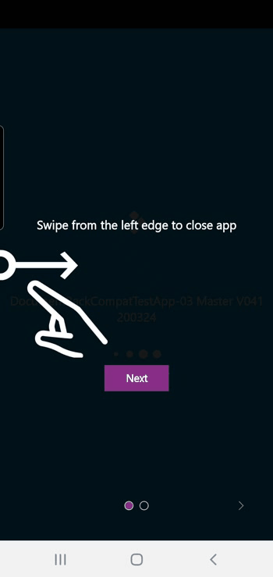

Figure 6 Close canvas app

## Close TDLR eInspection (Model Driven App)

Select the site map , and then select **Apps**.

Figure Close Model Driven App

## Go Offline – TDLR einspection(Model Driven App) - preferred

1. For the app to be available in offline mode, app and user data must be downloaded on your device. This process is called *initial offline sync*. Select Download to download offline data

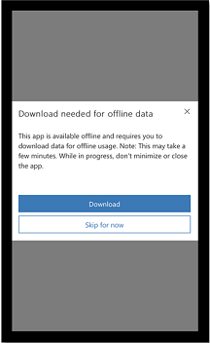

2. To test going offline select the Offline Status button

## Go Offline – TDLR eInspection Mobile(Canvas App)

1. For the app to be available in offline mode, app and user data must be downloaded on your device. This process is called *initial offline sync*. Select **Sync offline**

Figure Sync Offline data

1. Once you are offline select **Load Offline** to make offline data available for you to create inspections offline

Figure Load Offline data

# Desktop User Guide

## Environment Links

1. For the dashboard app:

Test URL: <https://org8d4c63e3.crm9.dynamics.com/main.aspx>

Production URL: <https://orga556fffe.crm9.dynamics.com/main.aspx>

1. For the mobile app:

TEST URL: <https://apps.gov.powerapps.us/play/06291b2f-854b-4c54-963f-470e593f8260?tenantId=eb8d3d3b-a14f-4a6a-ad4b-27283ad00df6>

Production URL: <https://apps.gov.powerapps.us/play/570a9186-bc69-4dd5-9b87-0589c1b9a257?tenantId=eb8d3d3b-a14f-4a6a-ad4b-27283ad00df6>

## Which environment am I in?

Click on the person icon to determine your environment.

* TDLR eInspections is Productions
* TDLR eInspections Test is Test
* TDLR eInspections Dev is Dev

Figure Click on the person icon to determine your environment

## Manager DTE Approvals

The Pre-requisite for the approvals to work properly is that the inspector have a region and a regional manager.

Any issues where approval are not being routed, or not being routed correctly check and make sure the inspector has a region and a regional manager as shown below

Figure 11 Active eInspections Users

## Approve DTE inspections from eInspection App

List of DTE inspections pending your approval as a manager or delegate approver are visible in the Manager Dashboard

1. Set the dashboard as the default dashboard

2. Select an inspection to start approval

3. In the Approval Status Field (1) select Approved if you approve. Select Corrections needed if the inspector must correct something.

4. Enter Comments(2). Select Finish or just save the record to complete the approval

Figure 12Approval screen in Dashboard eInspection

# References

<https://docs.microsoft.com/en-us/powerapps/mobile/run-powerapps-on-mobile1>.